

**Asia Pacific College**

**#3 Humabon Place, Magallanes, Makati City**

**PUBLIC SCHOOL RANKING SYSTEM**

**Project Documentation**

**Submitted to the Faculty of**

**School of Computing and Information Technologies**

**In Partial Fulfillment of the Requirements**

**for the subject Software Development**

Submitted by:

**AYUNGON, Rhea-Eve M.**

**BURTON, Kathrine Danielle C.**

**JULIAN, Kyla Joyce M.**

**LLANTOS, Joneil Thom O.**

Submitted to:

**Edmundo G. Casiño**

**Subject Professor**

**APRIL 26, 2018**

**Table of Contents**

**ABSTRACT** 3

**INTRODUCTION** 3

**I.** **PROJECT DESCRIPTION** 3

**II.** **TARGET CLIENT** 4

**III.** **BRIEF BACKGROUND** 4

**IV.** **PROBLEM STATEMENT** 4

**V.** **SITUATIONAL ANALYSIS** 4

**VI.** **PROPOSED SOLUTION** 5

**VII.** **EXPECTED OUTCOME** 5

**VIII.** **SYSTEM DIAGRAMS AND TABLES** 6

a. Context Level Diagram 6

*i.* *Moodle* 6

*ii.* *Optical Recognition Mark* 7

b. Organizational Chart of Program Modules 8

*i.* *Moodle* 8

*ii.* *Optical Recognition Mark* 9

c. Data Flow Diagram 10

d. Entity Relationship Diagram 11

*i.* *Moodle* 11

*ii.* *Optical Recognition Mark* 12

e. Database Structure / Data Tables 13

f. Data Dictionary 13

g. Screenshots per Module 13

**SOURCE CODE LISTINGS** 13

**REFERENCES** 13

# **ABSTRACT**

Ranking System is a project that can help schools be aware and help improve their students’ performance in their major subjects namely: Filipino, English, Mathematics, Science, and Araling Panlipunan through the help of Analytics. Together with the team’s client, Department of Education, they strive for excellence in the field of education in the Philippines.

# **INTRODUCTION**

Elementary education is the first part of the educational system, and it includes the first six years of compulsory education from grade 1 to 6, with an optional 7th grade offered by some schools. Major subjects include Mathematics, Science, English, Filipino and Araling Panlipunan.

The team believes that a student’s performance can be enhanced and strengthen with the help of analytics. Through a systematic analysis of data and statistics, the team, together with the client, Bureau of Education Assessment under Department of Education, may focus on students’ performance by viewing how the students perform in their major subjects. By acknowledging and knowing these factors, the teachers, together with their respective schools can keep track of their students’ performance and help them grow in their academics.

# **PROJECT DESCRIPTION**

How do we incorporate analytics in the academe? The team opted to use Moodle which is an online platform to administer Quarterly Assessment Exams. Each student will have an account and will automatically be enrolled in a course for their respective grade level. Once the students have answered all Quarterly Assessment Exams, the results will then be stored in the admin’s database containing the Student Name, Student ID, Exam Answers, and Answer Key.

The team, however, is very much conscious on the budget that will be allocated for the system. The team believes that implementing Moodle in every public school would require a huge budget allocation from DepEd. Therefore, another medium that can connect to analytics is the concept of Optical Mark Recognition (OMR) but proposing to replace the costly OMR machine using a regular ADF scanner. To facilitate this, Quarterly Exams are distributed in hard copies and would be scanned for checking. The results would also be extracted from the OMR to the system and would then be displayed on the dashboard for viewing.

# **TARGET CLIENT**

The project will be useful for the Bureau of Educational Assessment and will be beneficial to the Regional Directors, Division Superintendents down to the students.

# **BRIEF BACKGROUND**

The Department of Education (DepEd) in the Philippines is responsible for providing and maintaining quality education in the country. They are given the authority and privilege to regulate schools by implementing policies, plans, programs, and projects of formal and non-formal basic education. DepEd is responsible for overseeing all elementary and secondary education, as well as alternative learning systems whether it is public or private, and integrate system of basic education which is relevant to the goals of national development.

# **PROBLEM STATEMENT**

Aside from the fact that the system is not yet implemented in the country, it is also evident that quality education in public schools is compromised and needs improvement in technology. Also, due to the number of students in public school, it is only fair that teachers may be able to track their students’ performance with less hassle and stress.

# **SITUATIONAL ANALYSIS**

The problem stated above exists due to the philosophy opposing modern technology. It is hard and requires a huge amount of time to monitor the student’s progress throughout the school year without the intervention of technology because in the present situation, “eyeballing” is practiced in assessing data.

# **PROPOSED SOLUTION**

* Design a software which will be useful to evaluate student performance on OMR sheets. The system will be designed to process, extract and evaluate the scanned answer sheets.
* Build an exam generation system that is powered by Moodle to build and facilitate exams with a variety of questions and answers.
* Build a ranking system on a dashboard that can produce reports. This will help in tracking the school’s down to its student’s performance.

# **EXPECTED OUTCOME**

Once it is implemented, the system will be beneficial to its end-users namely regional directors, district superintendents, schools et cetera. The intermediate benefits are as following: (1) Improved access and data availability to academic performance (2) Improved exam assessment (3) Reduced errors in administering un-centralized exams (4) Improved accuracy and reliability of exam results (5) Reduced time to prepare reports.

# **SYSTEM DIAGRAMS AND TABLES**

## Context Level Diagram

### *Moodle*

A close up of a map

Description generated with high confidence

### *Optical Recognition Mark*

A screenshot of a cell phone

Description generated with very high confidence

## Organizational Chart of Program Modules

### *Moodle*

A screenshot of a cell phone

Description generated with high confidence

### *Optical Recognition Mark*

A screenshot of a cell phone

Description generated with high confidence

## Data Flow Diagram

A screenshot of a social media post

Description generated with very high confidence

## Entity Relationship Diagram

### *Moodle*

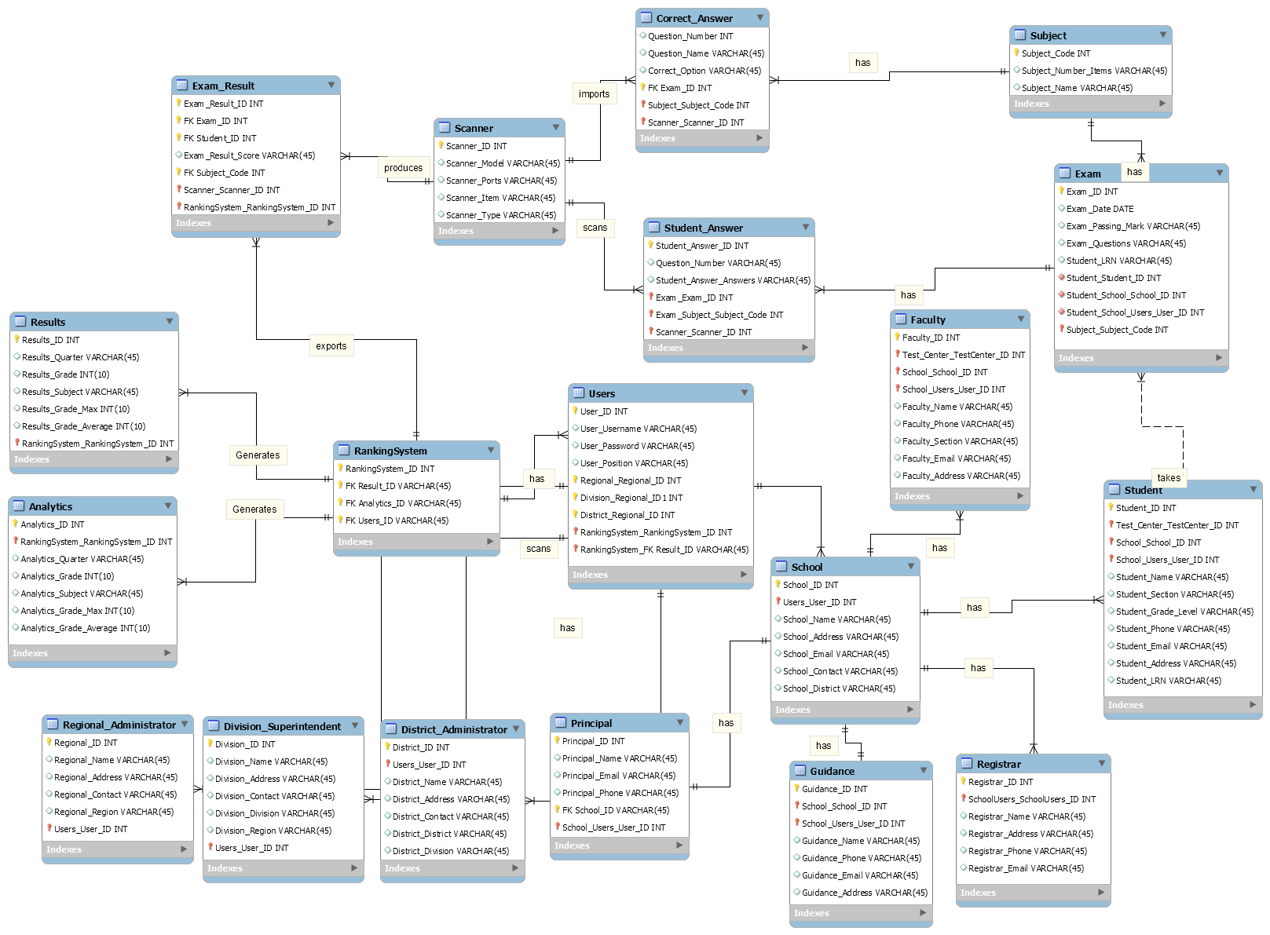

### *Optical Recognition Mark*

A screenshot of a computer

Description generated with very high confidence

## Database Structure / Data Tables

A screenshot of a cell phone

Description generated with very high confidence

## Data Dictionary

### *Users*

|  |  |  |  |  |
| --- | --- | --- | --- | --- |
| **REGIONAL DIRECTOR** | | | | |
| **Field Name** | **Data Type** | **Field Size** | **Description** | **Example** |
| Regional_ID | Integer | 11 | Unique number ID for all regional director | 764987 |
| User_ID | Integer | 11 | Unique number ID for all user | 387678 |
| School_ID | Integer | 11 | Unique number ID  for all school | 342134 |
| Regional_fname | Varchar | 20 | First name for regional director | Rhea |
| Regional_mname | Varchar | 20 | Middle name for guidance | Morales |
| Regional_lname | Varchar | 20 | Last name for regional director | Ayungon |
| Regional_region | Varchar | 10 | region location for regional director | NCR |
| Regional_address | Varchar | 50 | Address for regional director | Bangkal, Makati |
| Regional_email | Varchar | 20 | Email for regional director | Rmayungon2@gmail.com |
| Regional_contact | Integer | 11 | Contact for regional director | 09567890765 |

|  |  |  |  |  |
| --- | --- | --- | --- | --- |
| **DIVISION SUPERINTENDENT** | | | | |
| **Field Name** | **Data Type** | **Field Size** | **Description** | **Example** |
| Division_ID | Integer | 11 | Unique number ID for all division superintendent | 764987 |
| User_ID | Integer | 11 | Unique number ID for all user | 387678 |
| School_ID | Integer | 11 | Unique number ID  for all school | 342134 |
| Division_fname | Varchar | 20 | First name for division superintendent | Rhea |
| Division_mname | Varchar | 20 | Middle name for division superintendent | Morales |
| Division_lname | Varchar | 20 | Last name for division superintendent | Ayungon |
| Division_district | Varchar | 10 | District location for division superintendent | Ilocos Norte |
| Division_address | Varchar | 50 | Address for division superintendent | Ilocos Norte |
| Division_email | Varchar | 20 | Email for guidance | Rmayungon2@gmail.com |
| Division_contact | Integer | 11 | Contact for division superintendent | 09567890765 |

|  |  |  |  |  |
| --- | --- | --- | --- | --- |
| **DISTRICT ADMINISTRATOR** | | | | |
| **Field Name** | **Data Type** | **Field Size** | **Description** | **Example** |
| District_ID | Integer | 11 | Unique number ID for all principal | 764987 |
| User_ID | Integer | 11 | Unique number ID for all user | 387678 |
| School_ID | Integer | 11 | Unique number ID  for all school | 342134 |
| District_fname | Varchar | 20 | First name for principal | Rhea |
| District_mname | Varchar | 20 | Middle name for principal | Morales |
| District_lname | Varchar | 20 | Last name for principal | Ayungon |
| District_district | Varchar | 10 | District location for principal | NCR |
| District_address | Varchar | 50 | Address for principal | Bangkal, Makati |
| District_email | Varchar | 20 | Email for principal | Rmayungon2@gmail.com |
| District_contact | Integer | 11 | Contact for principal | 09567890765 |

|  |  |  |  |  |
| --- | --- | --- | --- | --- |
| **PRINCIPAL** | | | | |
| **Field Name** | **Data Type** | **Field Size** | **Description** | **Example** |
| Principal_ID | Integer | 11 | Unique number ID for all guidance | 764987 |
| User_ID | Integer | 11 | Unique number ID for all user | 387678 |
| School_ID | Integer | 11 | Unique number ID  for all school | 342134 |
| Principal_fname | Varchar | 20 | First name for guidance | Rhea |
| Principal_mname | Varchar | 20 | Middle name for guidance | Morales |
| Principal_lname | Varchar | 20 | Last name for guidance | Ayungon |
| Principal_district | Varchar | 10 | District location for guidance | NCR |
| Principal_address | Varchar | 50 | Address for guidance | Bangkal, Makati |
| Principal_email | Varchar | 20 | Email for guidance | Rmayungon2@gmail.com |
| Principal_contact | Integer | 11 | Contact for guidance | 09567890765 |

|  |  |  |  |  |
| --- | --- | --- | --- | --- |
| **GUIDANCE** | | | | |
| **Field Name** | **Data Type** | **Field Size** | **Description** | **Example** |
| Guidance_ID | Integer | 11 | Unique number ID for all guidance | 764987 |
| User_ID | Integer | 11 | Unique number ID for all user | 387678 |
| School_ID | Integer | 11 | Unique number ID  for all school | 342134 |
| Guidance_fname | Varchar | 20 | First name for guidance | Rhea |
| Guidance_mname | Varchar | 20 | Middle name for guidance | Morales |
| Guidance_lname | Varchar | 20 | Last name for guidance | Ayungon |
| Guidance_district | Varchar | 10 | District location for guidance | NCR |
| Guidance_address | Varchar | 50 | Address for guidance | Bangkal, Makati |
| Guidance_email | Varchar | 20 | Email for guidance | Rmayungon2@gmail.com |
| Guidance_contact | Integer | 11 | Contact for guidance | 09567890765 |

|  |  |  |  |  |
| --- | --- | --- | --- | --- |
| **REGISTRAR** | | | | |
| **Field Name** | **Data Type** | **Field Size** | **Description** | **Example** |
| Registrar_ID | Integer | 11 | Unique number ID for all registrar | 764987 |
| User_ID | Integer | 11 | Unique number ID for all user | 387678 |
| School_ID | Integer | 11 | Unique number ID  for all school | 342134 |
| Registrar_fname | Varchar | 20 | First name for registrar | Rhea |
| Registrar_mname | Varchar | 20 | Middle name for registrar | Morales |
| Registrar_lname | Varchar | 20 | Last name for registrar | Ayungon |
| Registrar_district | Varchar | 10 | District location for registrar | NCR |
| Registrar_address | Varchar | 50 | Address for registrar | Bangkal, Makati |
| Registrar_email | Varchar | 20 | Email for registrar | Rmayungon2@gmail.com |
| Registrar_contact | Integer | 11 | Contact for registrar | 09567890765 |

|  |  |  |  |  |
| --- | --- | --- | --- | --- |
| **TEACHER** | | | | |
| **Field Name** | **Data Type** | **Field Size** | **Description** | **Example** |
| Teacher_ID | Integer | 11 | Unique number ID for all teacher | 764987 |
| User_ID | Integer | 11 | Unique number ID for all user | 387678 |
| School_ID | Integer | 11 | Unique number ID  for all school | 342134 |
| Teacher_fname | Varchar | 20 | First name for teacher | Rhea |
| Teacher_mname | Varchar | 20 | Middle name for teacher | Morales |
| Teacher_lname | Varchar | 20 | Last name for teacher | Ayungon |
| Teacher_district | Varchar | 10 | District location for teacher | NCR |
| Teacher_address | Varchar | 50 | Address for teacher | Bangkal, Makati |
| Teacher_email | Varchar | 20 | Email for teacher | Rmayungon2@gmail.com |
| Teacher_contact | Integer | 11 | Contact for teacher | 09567890765 |

|  |  |  |  |  |
| --- | --- | --- | --- | --- |
| **STUDENT** | | | | |
| **Field Name** | **Data Type** | **Field Size** | **Description** | **Example** |
| Student_ID | Integer | 11 | Unique number ID for all student | 2015-10053 |
| User_ID | Integer | 11 | Unique number ID for all user | 387678 |
| School_ID | Integer | 11 | Unique number ID  for all school | 342134 |
| Student_fname | Varchar | 20 | First name for student | Rhea |
| Student_mname | Varchar | 20 | Middle name for student | Morales |
| Student_lname | Varchar | 20 | Last name for student | Ayungon |
| Student_district | Varchar | 10 | District location for student | NCR |
| Student_address | Varchar | 50 | Address for student | Bangkal, Makati |
| Student_email | Varchar | 20 | Email for student | Rmayungon2@gmail.com |
| Student_contact | Ineteger | 11 | Contact for student | 09567890765 |

### *Entities*

|  |  |  |  |  |
| --- | --- | --- | --- | --- |
| **EXAM** | | | | |
| **Field Name** | **Data Type** | **Field Size** | **Description** | **Example** |
| Exam_ID | Integer | 11 | Unique number ID for all exam | 434567 |
| Exam_Date | Date | 11 | Date for exam | 06/28/2018 |
| Exam_Passing_Mark | Integer | 11 | Passing Mark for exam | 70 |
| Exam_Max | Integer | 20 | Highest possible grade for an exam | 10 |
| Student_LRN | Varchar | 20 | Unique number ID for all students | 7137314 |
| Student_ID | Integer | 20 | Unique number ID for all students within school | 2015-10053 |
| Student_School | Varchar | 10 | School for students | Bangkal High School Main |
| Subject_Code | Integer | 7 | Subject code for exams | 6743256 |

|  |  |  |  |  |
| --- | --- | --- | --- | --- |
| **STUDENT ANSWER** | | | | |
| **Field Name** | **Data Type** | **Field Size** | **Description** | **Example** |
| Student_Answer_ID | Integer | 11 | Unique number ID for all student | 36236 |
| Question_Number | Varchar | 45 | Unique number ID for all question | 5 |
| Student_Answer | Varchar | 45 | Answer for student | A |
| Exam_ID | Integer | 11 | Unique number ID for all exam | 567 |
| Student_LRN | Varchar | 20 | Unique number ID for all students | 263572 |
| Subject_Code | Integer | 20 | Subject code for exams | 6743256 |
| Scanner_ID | Integer | 11 | Unique number ID for scanner | 34873 |

|  |  |  |  |  |
| --- | --- | --- | --- | --- |
| **SCANNER** | | | | |
| **Field Name** | **Data Type** | **Field Size** | **Description** | **Example** |
| Scanner_ID | Integer | 11 | Unique number ID for scanner | 6724 |
| Scanner_Model | Varchar | 45 | Model of a scanner | KV-S6789 |
| Scanner_Ports | Varchar | 45 | Ports of a scanner | USB |
| Scanner_Item | Varchar | 11 | Unique number item ID for all scanner | KST-5578 |
| Scanner_Type | Varchar | 20 | Type of a scanner | ADF |

|  |  |  |  |  |
| --- | --- | --- | --- | --- |
| **SCHOOL** | | | | |
| **Field Name** | **Data Type** | **Field Size** | **Description** | **Example** |
| School_ID | Integer | 11 | Unique number ID for all school | 543757 |
| School_Name | Varchar | 45 | Name of school | Bangkal Main High school |
| School_Address | Varchar | 45 | Address for schools | Bangkal, Makati |
| School_Principal | Varchar | 45 | Principal of school | Rhea Ayungon |
| School_District | Integer | 11 | District location of school | Makati |
| School_Division | Varchar | 20 | Division location of school | Makati |
| School_Region | Integer | 20 | Region location of school | NCR |
| Student_ID (FK) |  |  |  |  |
| School_Budget | Integer | 20 | Budget for schools | 6,000,000 |
| School_Population | Inetger | 20 | Population for schools | 600 |

|  |  |  |  |  |
| --- | --- | --- | --- | --- |
| **RESULTS** | | | | |
| **Field Name** | **Data Type** | **Field Size** | **Description** | **Example** |
| Results_ID | Integer | 11 | Unique number ID for all student | 356355 |
| Results_Quarter | Varchar | 45 | Unique number ID for all question | 1st Quarter |
| Results_Grade | Integer | 11 | Grade of a result | 8 |
| Results_Subject | Varchar | 45 | Result for a specific subject | Science |
| Results_Average | Integer | 20 | Average score of a result | 5 |

|  |  |  |  |  |
| --- | --- | --- | --- | --- |
| **ANALYTICS** | | | | |
| **Field Name** | **Data Type** | **Field Size** | **Description** | **Example** |
| Analytics_ID | Integer | 11 | Unique number ID for the analytics | 356777 |
| Analytics_Quarter | Varchar | 45 | Quarter for Analytics result | 1st Quarter |
| Analytics_Grade | Integer | 11 | Grade of a result | 10 |
| Analytics_Subject | Varchar | 45 | Analytic result for a subject | Science |

## Screenshots per Module

# **SOURCE CODE LISTINGS**

# **REFERENCES**

*(Software Analysis & Design Tools,* 2018*)*

*About DepEd*. (n.d.). From Department of Education: http://www.deped.gov.ph/mandate

*About Moodle*. (2018, March 1). From Moodle: https://docs.moodle.org/34/en/About_Moodle

Automatic Document Feeder (ADF). (2018). *Technopedia*.

Balderas, D. D. (2017). Division Memorandum No. 396. *Conduct of Quarter Tests*.

Gravic. (2018). What is OMR (Optical Mark Recognition)? *Remark*.

Inc., P. (2018). Quality Assurance Manager Salary. *PayScale*.

Maria Celia Junio-Fernandez, E. (2017). Division Policy Guidelines on the Administration of Quarterly Examination. *Schools Division Office*, 1.

PHP. (2018). *What is PHP?*, http://php.net/manual/en/intro-whatis.php.

PricePrice. (2018, April 13). *ph.priceprice.com*. From Priceprice.com: http://ph.priceprice.com/Acer-Aspire-E5-475G-24799/

Roseke, B. (2018). What is Project Deliverable? *Project Engineer*.

Siegelaub, J. M. (2007). Six (yes six!) Constraints. *An Enhanced Model for Project Control*.

Work Breakdown Structure. (2018). *Work Breakdown Structure (WBS)*, http://www.workbreakdownstructure.com/.

Yakubovitch, M. (2015). Project Management. *How to Define Project Deliverables*.